CustomButton v1.5 Add-in
Functional Understanding Document
Version 1.3

Table of Contents
1 Introduction 4
1.1 What is CustomButton? 4
2 Installation of CustomButton v1.5.xlam 4
2.1.1 Downloading the CustomButton Add-in 4
2.1.2 Important: Unblocking the Add-in 5
3 Working with CustomButton 6
3.1 Referencing CustomButton in VBA 6
4 CustomButtons “Quick Start” Guide 7
4.1 ShowUserFormCode() Function 7
4.2 Deleting the Legacy CommandButtons 9
4.3 _Entry and _Exit Events 9
4.4 FindWindow() Windows API 9
4.5 CentreUserForm() Function 9
5 Functional Specifications 10
5.1 Class CustomButtons 10
5.1.1 .Create() Method 10
5.1.2 .DistroyAll() Method 11
5.1.3 .ShowUserFormCode() Method 12
5.1.4 .ExcelGreen Property 12
5.1.5 .Trace Property 13
5.2 Class CustomButton 14
5.2.1 Event Support 14
5.2.2 Methods 14
5.2.3 Properties 15
5.2.4 Style & Color Properties 16
6 Current Limitations of CustomButton 16
6.1 Windows 11 Visual Parity 16
6.2 Future Property Roadmap 17
7 Conclusion 17

List of Tables
Table 5-1: CustomButtons Class Methods 10
Table 5-2: CustomButtons Class Properties 10
Table 5-3: CustomButtons.Create() Parameters 11
Table 5-4: CustomButtons.DistoryAll() Parameters 12
Table 5-5: CustomButtons.ShowUserFormCode() Parameters 12
Table 5-6: CustomButtons.ExcelGreen Porperty 13
Table 5-7: CustomButtons.Tracen Porperty 14
Table 5-8: CustomButton Methods 14
Table 5-9: CustomButton Methods 15
Table 5-10: Default Color Schemes by Operating System / Application 16
Table 6-1 Unsupported CustomButton Properties 17

List of Figures
Figure 1-1: Sample Userform with CustomButtons 4
Figure 2-1: Excel Add-ins Folder 5
Figure 2-2: Unblock Downloaded CustomButton Add-in 6
Figure 3-1: Adding CustomButton_v1_5 as a Reference 7
Figure 4-1: ShowUserFormCode() Output 8

Introduction
Welcome to CustomButton, a modern UI framework for Microsoft Excel.
For decades, VBA developers have been restricted to the "Legacy" aesthetic of standard Windows controls—designs that have remained largely unchanged since the mid-1990s. While functional, these controls often feel out of place in the modern professional landscape of Windows 10 and 11.

CustomButton was developed to bridge this gap.

What is CustomButton?
CustomButton is a lightweight Microsoft Excel Add-in designed to modernize the legacy VBA UserForm interface. CustomButton replicates the clean, minimalist aesthetic of Windows 10 & 11, replacing the dated look of standard UserForm CommandButtons with a contemporary design.

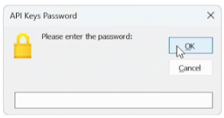
Figure 1-1: Sample Userform with CustomButtons

Installation of CustomButton v1.5.xlam
Follow the steps below to install the CustomButton add-in and integrate it with Microsoft Excel. These steps ensure the library is correctly registered and available for use within the VBA Editor.

Downloading the CustomButton Add-in
To install the Add-in, download the CustomButton v1.5.xlam file from the GitHub repository and move it to the local Microsoft Add-ins directory:

C:\Users\[YourUsername]\AppData\Roaming\Microsoft\AddIns

Note: Replace [YourUsername] with your active Windows login name.

Quick Access Shortcut:
Alternatively, you can access this folder directly by pasting the following environment variable into the File Explorer address bar:

%appdata%\Microsoft\AddIns

Once the folder is open, drag and drop the CustomButton v1.5.xlam file from your Downloads folder into the Addins folder as in Figure 2-1.

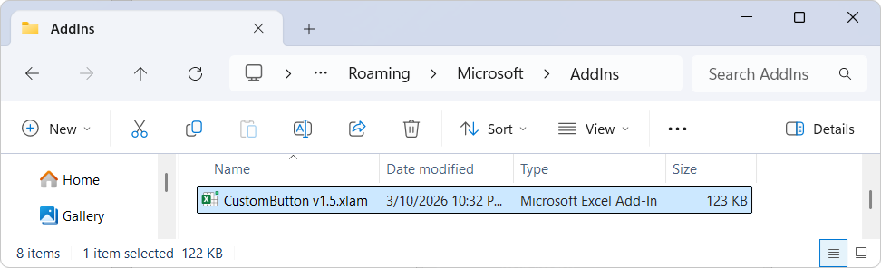
Figure 2-1: Excel Add-ins Folder

Important: Unblocking the Add-in
Because the file was downloaded from an external source (GitHub), Windows will apply a 'Mark of the Web' security attribute, which prevents the Add-in from executing macros. Even if the file is placed in the correct directory, it will not function until it is manually unblocked.

To unblock the Add-in:
- Navigate to the %appdata%\Microsoft\AddIns folder
- Right-click the CustomButton v1.5.xlam file.
- Select Properties.
- At the bottom of the General tab, look for Security.
- Check the Unblock box and click Apply.

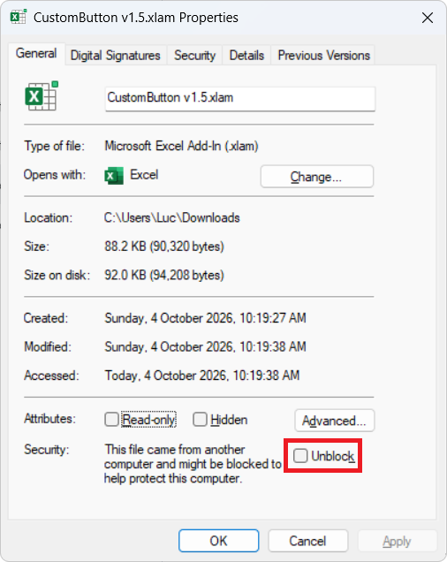
Figure 2-2: Unblock Downloaded CustomButton Add-in

Working with CustomButton
Before the CustomButton class can be utilized within your UserForms, it must be properly initialized within the VBA environment. This involves linking the Add-in to your specific workbook and ensuring the VBA compiler can access the library’s properties and methods.

Referencing CustomButton in VBA
Once the Add-in is installed and unblocked, you must establish a reference to the library within your specific VBA Project. This allows the VBA compiler to recognize the CustomButton class and provide IntelliSense support while coding.

Follow these steps to enable the reference:
- Open Excel.
- Go to the Developer tab (If you don't see it, right-click any ribbon tab > Customize the Ribbon > Check "Developer").
- Click View Code.
- Go to the Tools menu > References.. and locate CustomButton_v1_5 and select it as in Figure 3-1. A tick mark will appear next to CustomButton_v1_5.
- Click OK.

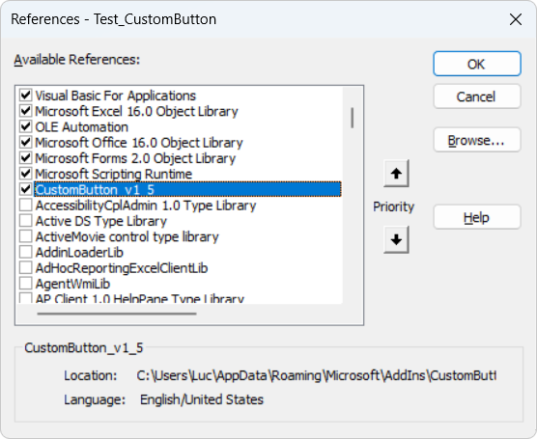
Figure 3-1: Adding CustomButton_v1_5 as a Reference

At this stage the add-in is now available to use in your UserForms.

CustomButtons “Quick Start” Guide
Follow the steps below to add a CustomButton to your UserForm. This process allows you to quickly replace standard legacy CommandButtons with the CustomButton class, providing an immediate visual upgrade to your interface at run time.

ShowUserFormCode() Function
For existing UserForms, the most efficient method for migrating from legacy controls to CustomButtons is utilizing the ShowUserFormCode() function. By passing the Me keyword as a parameter at the conclusion of the UserForm_Initialize() event, the function generates the necessary boilerplate code. Upon execution, the Immediate Window displays the specific code required to be merged back into the UserForm module, as illustrated in Figure 4-1. The example below demonstrates the implementation, for the required integration:

Private Sub UserForm_Initialize()
Dim hWnd As LongPtr

With SampleForm
.Height = 180# 'fix screen driver issue
.Width = 240#

.StartUpPosition = 0 'allow manual positioning

hWnd = FindWindow("ThunderDFrame", .Caption)
CentreUserForm hWnd
End With

'generates boilerplate code in the Immediate Window
CustomButtons.ShowUserFormCode Me
End Sub

Note: Functions FindWindow() and CentreUserForm() are both included in the CustomButton add-in and available to use once the add-in is correctly registered in your project. See Section 3.1 for more information on registering the CustomButton add-in.
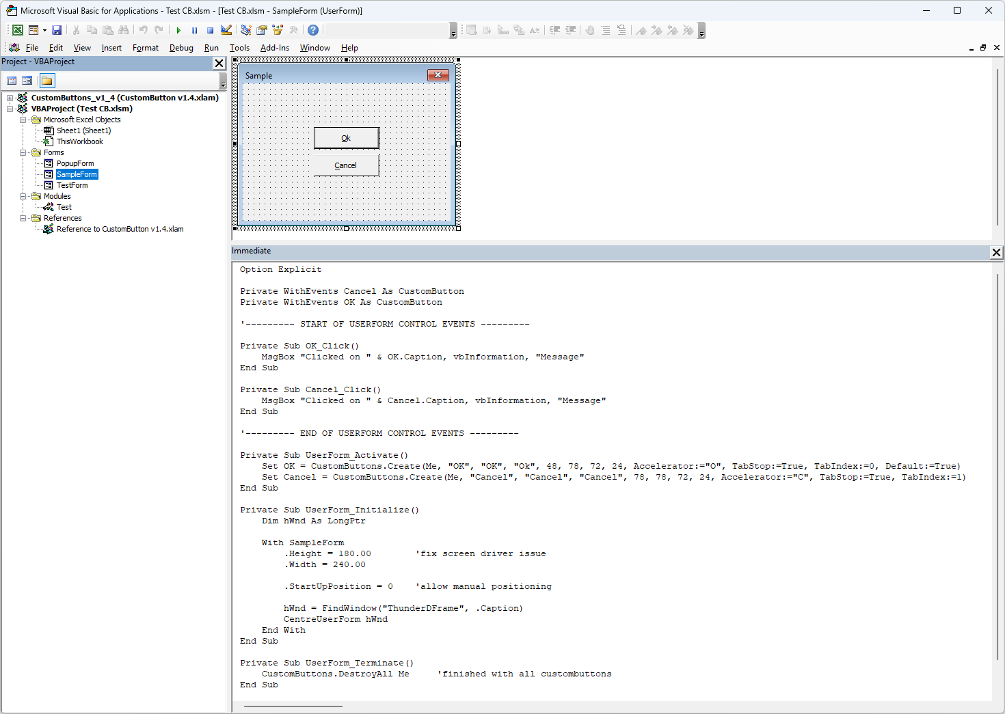
Figure 4-1: ShowUserFormCode() Output

Merge the required code segments from the Immediate Window back into your UserForm code. After integration is complete, navigate to Section 4.2 for instructions on removing the original CommandButtons.

Deleting the Legacy CommandButtons
Deleting the original CommandButtons is a critical requirement of the migration process. Because the CustomButton class dynamically instantiates its own controls using the original naming convention, maintaining duplicate button names will result in a naming conflict. Failure to remove the legacy button prior to execution will trigger a Runtime Error.

_Entry and _Exit Events
Due to native VBA limitations, custom classes cannot directly sink the standard _Exit event of a control. To provide this functionality, the CustomButton class utilizes the _OnExit events instead and for consistency the _OnEnter event. If your existing UserForm logic relies on either of these events, you must rename your subroutines to match the class requirements as shown below:

Private Sub Button1_OnEnter()
'Button1 enter code goes here
End Sub

Private Sub Button1_OnExit(ByVal Cancel As MSForms.ReturnBoolean)
'Button1 exit code goes her
End Sub

FindWindow() Windows API
The FindWindow() API function is included as a dedicated utility to retrieve the hWnd (Window Handle) of the UserForm. This handle is used exclusively to calculate the form's precise coordinates on the screen, ensuring the UserForm is correctly centered within the Excel application window.

The implementation utilizes conditional compilation (PtrSafe and LongPtr) to ensure full compatibility across both 32-bit and 64-bit Excel environments. By obtaining the hWnd, the CustomButton class can bypass standard VBA positioning limitations, providing a more consistent user experience on high-resolution or multi-monitor configurations.

CentreUserForm() Function
The CentreUserForm() function is a layout utility designed to align the UserForm precisely within the boundaries of the main Excel application window. This function requires a single parameter—the hWnd (Window Handle) retrieved in the previous step—to calculate the parent window's coordinates.

Unlike the native VBA StartUpPosition property, which defaults to the center of the physical screen, CentreUserForm() ensures the interface remains contained within the active Excel workspace. This provides a more cohesive user experience, particularly for users operating on ultra-wide or multi-monitor setups where a screen-centered form may appear disconnected from the application.

Functional Specifications
This section provides a technical overview of the public classes, methods, and properties available within the CustomButton framework. These components allow for the programmatic initialization, management, and customization of your UserForm interface.

Class CustomButtons
The CustomButtons class serves as the primary engine for the library. It manages the global state of all button instances and is the core class pre-defined within the CustomButton add-in. The following methods are used to initialize and manage the button lifecycle:

Method | Description
Create | Initializes and renders a new button instance on the UserForm.
DestroyAll | Terminates all active button instances and clears them from memory.
ShowUserFormCode | Scans the current UserForm and generates the necessary boilerplate code for integration.
Table 5-1: CustomButtons Class Methods

The following properties allow for global configuration of the button environment:

Property | Note
ExcelGreen | A Boolean property to toggle the signature "Excel Green" theme across all buttons.
Trace | A debugging utility that enables or disables execution logs for troubleshooting.
Table 5-2: CustomButtons Class Properties

.Create() Method
The .Create() method is the primary constructor used to instantiate modern buttons within a VBA project. It supports deployment on standard UserForms as well as nested containers (Frames and MultiPage controls).

The method returns a CustomButton class object. Because this returns an object, the Set keyword must be used when assigning the result to a variable.

Syntax Example:

Set Button1 =
CustomButtons.Create(Me, "Button1", "Submit1", "Submit", 10, 10)

The following table outlines the arguments available for the .Create() method:

Parameters | Required | Type | Default Value | Note
Parent | Yes | Object |  | UserForm, Frame or Multipage handle
VariableName | Yes | String |  | Declared variable Name
Name | Yes | String
Caption | Yes | String
Top | Yes | Single |  | In points
Left | Yes | Single |  | In points
Width | - | Single | 68 | In points
Height | - | Single | 20 | In points
FontName | - | String | Tahoma
FontSize | - | Single | 8 | In points
FontBold | - | Boolean | False
FontItalic | - | Boolean | False
FontUnderline | - | Boolean | False
FontStrikethrough | - | Boolean | False
ControlTipText | - | String |  | Empty by default
Accelerator | - | String |  | Empty by default
Cancel | - | Boolean | False | ESC triggers a button click
TabIndex | - | Integer | -1
TabStop | - | Boolean | True
MousePointer | - | Integer | 0 | fmMousePointerDefault
MouseIcon | - | StdPicture | Nothing
Tag | - | String |  | Store custom data string with button
Default | - | Boolean | False
Visible | - | Boolean | True
Locked | - | Boolean | False | Has no effect on a button
Enabled | - | Boolean | True
HelpContextID | - | Integer | 0 | This value is ignored
Table 5-3: CustomButtons.Create() Parameters

.DistroyAll() Method
The .DestroyAll() method is used to terminate all active button instances within a specific container and release them from memory. This is particularly useful when a UserForm is being closed or when a container (such as a Frame) needs to be cleared and re-populated dynamically.

By passing the parent object as a parameter, the method identifies all associated CustomButton objects and ensures they are safely disposed of, preventing orphaned objects from lingering in memory.

Syntax Example

Private Sub UserForm_Terminate()
'clean up all custom buttons when the form closes
CustomButtons.DestroyAll Me
End Sub

The following table outlines the arguments required for the .DestroyAll() method:

Parameter | Required | Type | Note
Parent | Yes | Object | Handle from a UserForm, Frame or Multipage. Often will be the keyword Me.
Table 5-4: CustomButtons.DistoryAll() Parameters

.ShowUserFormCode() Method
The .ShowUserFormCode() method is a productivity utility designed to simplify the integration of CustomButton logic into your project. When called, it scans the specified parent container and generates a ready-to-use block of VBA code in the Immediate Window.

This generated code includes the necessary variable declarations and event handlers (e.g., Click, Hover, and MouseMove) for every button identified within the container. This eliminates the need for manual coding and ensures that all event signatures are technically correct. See Section 4.1 for an usage example.

The following table outlines the arguments required for the .ShowUserFormCode() method:

Parameter | Required | Type | Note
Parent | Yes | Object | Handle from a UserForm, Frame or Multipage. Often will be the keyword Me.
Table 5-5: CustomButtons.ShowUserFormCode() Parameters

.ExcelGreen Property
The .ExcelGreen property is a global Boolean flag that determines the default color scheme for all button instances created after the property is set. When enabled, buttons are rendered using a professional palette inspired by the Microsoft Excel branding, providing a seamless "native" look for your add-in.

Setting this property to False (default) allows buttons to use standard minimalist styling or custom colors defined at the individual button level.

Usage Example

'apply Excel branding globally before creating buttons
CustomButtons.ExcelGreen = True

The following table describes the impact of the .ExcelGreen setting:

Property | Value
ExcelGreen | True will apply a specific color palette to match Excel green colors. False will revert back to either Windows 10 or 11 colors. See Table 5-10.
Table 5-6: CustomButtons.ExcelGreen Porperty

.Trace Property
The .Trace property is a diagnostic utility used to output real-time execution data to the VBA Immediate Window. By assigning specific constants to this property, developers can isolate and troubleshoot specific behaviours—such as event triggers, layout rendering, or object creation—without wading through unnecessary log data.

This property supports bitwise-style constants, allowing for high-precision debugging during the development and testing phases of your UserForm.

Syntax Example

' Enable logging for events and creation only
CustomButtons.Trace = TR_EVENTS + TR_CREATE

The following constants can be assigned to the .Trace property to define the logging level:

Constant | Description
TR_NONE | Disables all diagnostic logging (Default).
TR_EVENTS | Logs interaction events (Click, DblClick, Enter, Exit).
TR_METHODS | Logs calls to internal and public methods.
TR_PROPERTIES | Logs changes to button property values.
TR_LAYOUTCOLORS | Logs rendering data related to themes and color schemes.
TR_USERFORM | Logs interactions specifically related to the host UserForm.
TR_MOUSEMOVE | Logs high-frequency mouse movement data.
TR_CREATE | Logs data during the instantiation and initialization phase.
TR_DESTROYALL | Logs the disposal and memory release process.
TR_OVERRIDEDEFAULT | Logs instances where default behaviors are bypassed.
TR_ALL | Enables all available logging levels simultaneously.
Table 5-7: CustomButtons.Tracen Porperty

Class CustomButton
The CustomButton class represents an individual button instance created via the CustomButtons.Create() method. This class acts as a sophisticated bridge between the user’s mouse/keyboard actions and the UserForm, managing internal state while exposing standard events and properties to the developer.

Event Support
The class listens for and passes the following events through to your project. This allows CustomButtons to behave identically to native controls while utilizing a modern render engine.
- Click / DblClick
- MouseDown / MouseUp / MouseMove
- KeyPress / KeyDown / KeyUp
- OnEnter / OnExit (Focus events)
- BeforeUpdate / AfterUpdate

Methods
Use these methods to programmatically control a specific button instance:

Method | Description
Repaint | Forces the button to re-render its visual state (useful after changing colors or captions).
SetFocus | Programmatically moves the keyboard focus to the button.
Table 5-8: CustomButton Methods

Properties
These properties allow you to read or modify the button’s state at runtime.

Property | Type | Access | Note
.Parent | Object | Read-Only | Returns the container (UserForm/Frame/ Multipage) holding the button.
.ParentHwnd | LongPtr | Read-Only | Window handle of the container (UserForm/Frame/Multipage).
.VarName | String | Read-Only | Returns the name assigned to the variable in VBA.
.Name | String | Read-Only | Returns the internal name of the control.
.Caption | String | Read/Write | The text displayed on the button surface.
.Top | Single | Read/Write | The position of the button top in points.
.Left | Single | Read/Write | The position of the button left in points.
.Width | Single | Read/Write | The dimensions of the button width in points.
.Height | Single | Read/Write | The dimensions of the button height in points.
.Font | Object | Read-Only | Access to the font sub-object.
.Font.Name | String | Read/Write | Recommended: 'Segoe UI' for modern OS feel.
.Font.Size | Single | Read/Write | Recommended: 8.5 for high-density UIs.
.ControlTipText | String | Read/Write | The tooltip displayed for the button.
.Accelerator | String | Read/Write | The hotkey (Alt + Key) for the button.
.Cancel | Boolean | Read/Write | Set to True to map the button to the Esc key.
.Default | Boolean | Read/Write | Set to True to map the button to the Enter key.
.TabIndex | Integer | Read/Write | The order of the button in the keyboard Tab sequence.
.TabStop | Boolean | Read/Write | Determines if the button can receive focus via the Tab key.
.MousePointer | Integer | Read/Write | Set the mouse pointer to a pre-defined constants.
.MouseIcon | StdPicture | Read/Write | Set the mouse pointer to a custom cursor or picture.
.Tag | String | Read/Write | A storage string for developer-defined metadata.
.Visible | Boolean | Read/Write | Toggles the button’s visibility.
.Locked | Boolean | Read/Write | Has no effect on a button.
.Enabled | Boolean | Read/Write | Toggles user interactivity and "greyed-out" state.
. HelpContextID | Integer | Read/Write | Legacy help file context ID. This value is Ignored.
Table 5-9: CustomButton Methods

Style & Color Properties
The CustomButton class allows for granular control over the control's visual states (Normal, Hover, Pressed, and Disabled). To assist with UI consistency, the following table provides the default RGB values for achieving a "Native" look across different environments.

Property (Color) | Windows 10  (Classic) | Windows 11 (Fluent) | Excel (Signature Green)
.BackColor | RGB(225, 225, 225) | RGB(251, 251, 251) | —
.BorderColor | RGB(173, 173, 173) | RGB(229, 229, 229) | —
.ForeColor | RGB(0, 0, 0) | RGB(0, 0, 0) | —
.HoverBackColor | RGB(229, 241, 251) | RGB(224, 238, 249) | RGB(233,245,238)
.HoverDownColor | RGB(204, 228, 247) | RGB(204, 228, 247) | RGB(159,205,179)
.HoverBorderColor | RGB(0, 120, 215) | RGB(0, 120, 212) | RGB(78,150,104)
.HoverForeColor | RGB(0, 0, 0) | RGB(0, 0, 0) | —
.DisabledBackColor | RGB(204, 204, 204) | RGB(249, 249, 249) | —
.DisabledBorderColor | RGB(191, 191, 191) | RGB(233, 233, 233) | —
.DisabledForeColor | RGB(131, 131, 131) | RGB(158, 158, 158) | —
.DefaultBorderColor | RGB(0, 120, 215) | RGB(0, 103, 192) | RGB(78,150,104)
Table 5-10: Default Color Schemes by Operating System / Application

Current Limitations of CustomButton
While CustomButton offers extensive customization, it is important to acknowledge its current technical boundaries. I believe in providing full transparency regarding our development progress so that you can make informed decisions when integrating this component into your projects. The following section outlines our current visual and functional limitations, as well as the specific properties slated for future updates.

Windows 11 Visual Parity

Currently, CustomButton does not render the rounded corner geometry standard in Windows 11. Additionally, it does not yet support the Fluent Design System’s dynamic color logic.

In Windows 11, button aesthetics are determined at runtime through backplate transparency and color blending. Rather than using a static palette, the system takes a single Accent Color and applies mathematical transformations based on the user's theme (Light or Dark mode). The final button color is achieved by subtly blending these calculated values with the background material (such as Mica or Acrylic), ensuring the UI remains cohesive regardless of the desktop wallpaper or application state.

Development Note: Work has officially begun on implementing the Windows 11 color logic; I am currently developing the engine that utilizes the single system Accent color to dynamically calculate the full spectrum of required button states and shades.

Future Property Roadmap

The following properties are currently not implemented and have not yet been exposed in the current version of the Add-in. These are slated for development in a future update:

Category | Property
Sizing & Layout | .AutoSize, .WordWrap
Visuals & Imagery | .BackStyle, .Picture, .PicturePosition
User Interaction | .TakeFocusOnClick
Table 6-1 Unsupported CustomButton Properties

Conclusion
Thank you for choosing CustomButton.

The goal is to provide a robust, flexible UI component that bridges the gap between standard Microsoft Add-in functionality and modern design standards.

I hope the current feature set empowers you to create more professional and intuitive user interfaces. As the "Future Property Roadmap" indicates, I am committed to continuous improvement and expanding the capabilities of this Add-in.

